1. Number of cases by week and month in continent

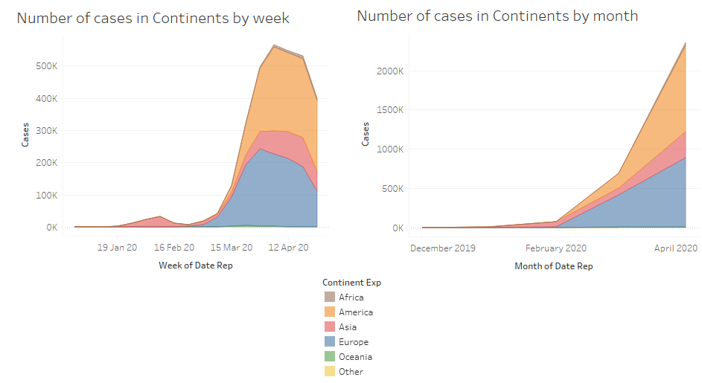

1. Number of deaths by week and month in continents

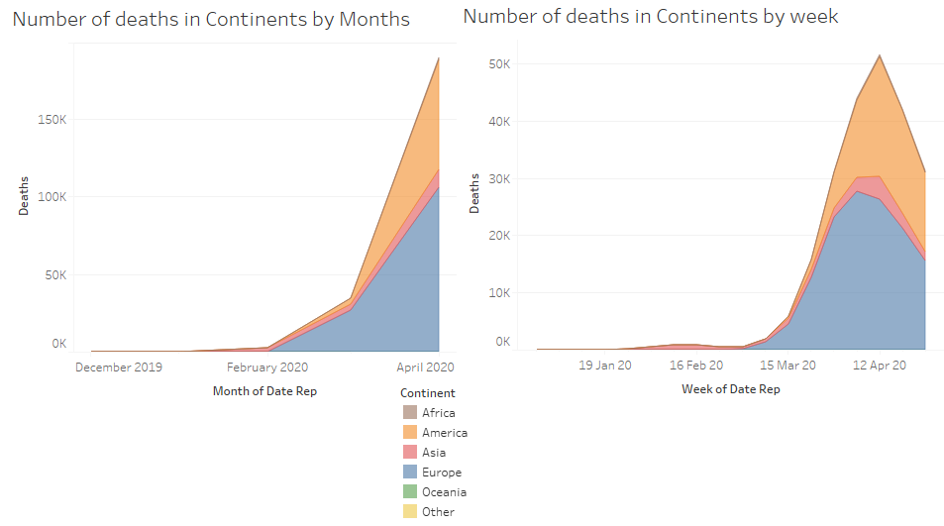

1. Cases by countries

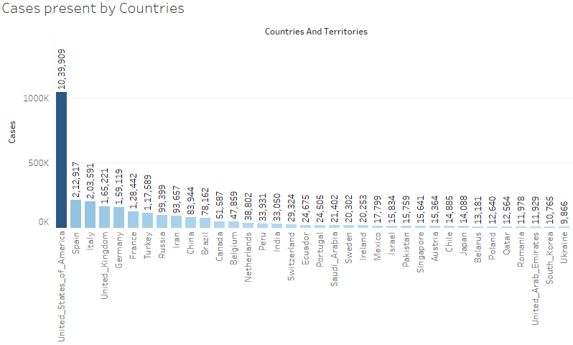

1. Deaths by Countries

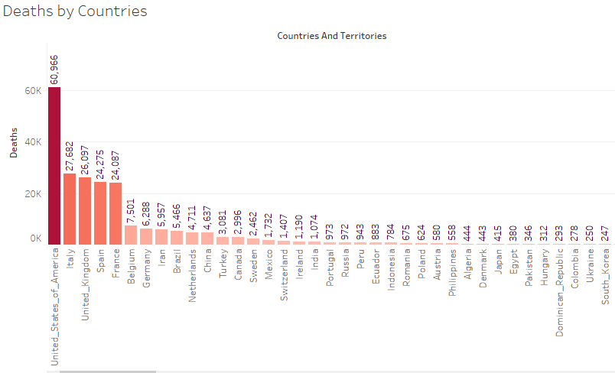

1. Cases vs Deaths in America per day

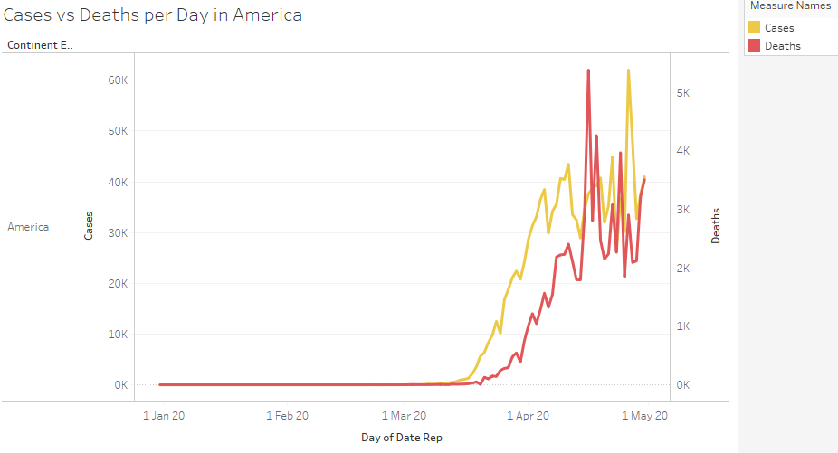

1. Geospatial visualisation of continents with cases of corona.

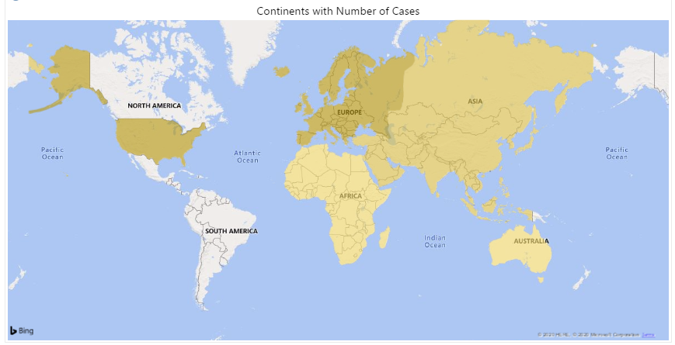

1. Geospatial visualisation of continents with deaths of corona.

